**CL-IX (Distributed Computing Systems Lab)**

Assignment 5

**Roll no :** 43159

**Name :** Sakshi Tantak

**Batch :** P-11

**Title:** To create a simple web service and write any distributed application to consume the web service.

**Tools:**​ Java 8, Eclipse with tomcat

**Theory:**

**Web Services:**

* A Web service is a method of communication between two applications or electronic devices over the World Wide Web (WWW).
* A web service can be defined as a collection of open protocols and standards for exchanging information among systems or applications.
* A Web service is an abstract notion that must be implemented by a concrete agent. The agent is the concrete piece of software or hardware that sends and receives messages, while the service is the resource characterized by the abstract set of functionality that is provided.

**The architecture of Web Services:**

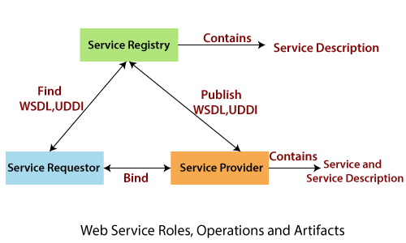

**Some key terms:**

* **SOAP:** Simple Object Access Protocol
* **WSDL:** Web Service Description Language
* **UDDI:** Universal description and Discovery protocol
* **Service Registry:** Central place where services are listed and looked up

**Types of Web Services:**

**There are two types of web services:**

* SOAP-Based Web Services:

SOAP stands for Simple Object Access Protocol. SOAP is an XML-based industry-standard protocol for designing and developing web services. Since it’s XML-based, it’s platform and language independent. So, our server can be based on JAVA and the client can be on .NET, PHP, etc., and vice versa.

* RESTful Web Services:

REST (Representational State Transfer ) is an architectural style for developing web services. It’s getting popular recently because it has a small learning curve when compared to SOAP. Resources are core concepts of Restful web services and they are uniquely identified by their URIs

**SOAP vs REST**

|  |  |  |
| --- | --- | --- |
| **No.** | **SOAP** | **REST** |
| 1) | SOAP is a protocol. | REST is an architectural style. |
| 2) | SOAP stands for Simple Object Access Protocol. | REST stands for REpresentational State Transfer. |
| 3) | SOAP can't use REST because it is a protocol. | REST can use SOAP web services because it is a concept and can use any protocol like HTTP, SOAP. |
| 4) | SOAP uses services interfaces to expose the business logic. | REST uses URI to expose business logic.` |
| 5) | JAX-WS is the java API for SOAP web services. | JAX-RS is the java API for RESTful web services. |
| 6) | SOAP defines standards to be strictly followed. | REST does not define too much standards like SOAP. |
| 7) | SOAP requires more bandwidth and resources than REST. | REST requires less bandwidth and resources than SOAP. |
| 8) | SOAP defines its own security. | RESTful web services inherit security measures from the underlying transport. |
| 9) | SOAP permits XML data format only. | REST permits different data formats such as Plain text, HTML, XML, JSON etc. |
| 10) | SOAP is less preferred than REST. | REST is more preferred than SOAP. |

**Steps Involved In Basic Soap Web Service**

OPERATIONAL BEHAVIOUR

The following are the steps involved in a basic SOAP web service operational behavior:

1. The client program that wants to interact with another application prepares its request content as a SOAP message.
2. Then, the client program sends this SOAP message to the server web service as an HTTP POST request with the content passed as the body of the request.
3. The web service plays a crucial role in this step by understanding the SOAP request and converting it into a set of instructions that the server program can understand.
4. The server program processes the request content as programmed and prepares the output as the response to the SOAP request.
5. Then, the web service takes this response content as a SOAP message and reverts to the SOAP HTTP request invoked by the client program with this response.
6. The client program web service reads the SOAP response message to receive the outcome of the server program for the request content it sent as a request.

**Java provides its own API to create both SOAP as well as RESTful web services.**

1. **JAX-WS:** JAX-WS stands for Java API for XML Web Services. JAX-WS is an XML based Java API to build web services server and client applications.

2. **JAX-RS:** Java API for RESTful Web Services (JAX-RS) is the Java API for

creating REST web services. JAX-RS uses annotations to simplify the development and deployment of web services.

Both of these APIs are part of standard JDK installation, so we don’t need to

add any jars to work with them.

**Creating a SOAP web service:**

1. Create a java class with a method that you want to publish as a service.
2. Right Click -> New -> Other and select Web service .
3. In service implementation, make sure that your class name is selected.
4. Drag the slider to the top and create both test service and test client.
5. Check Publish web service and monitor web service option.
6. Click on next and select the method you want to publish
7. In style and use section selected document/literal wrapped
8. Click on finish. Now web service will be published on the tomcat server
9. Now select the method in the test client and test the webservice.

**Output(s):**

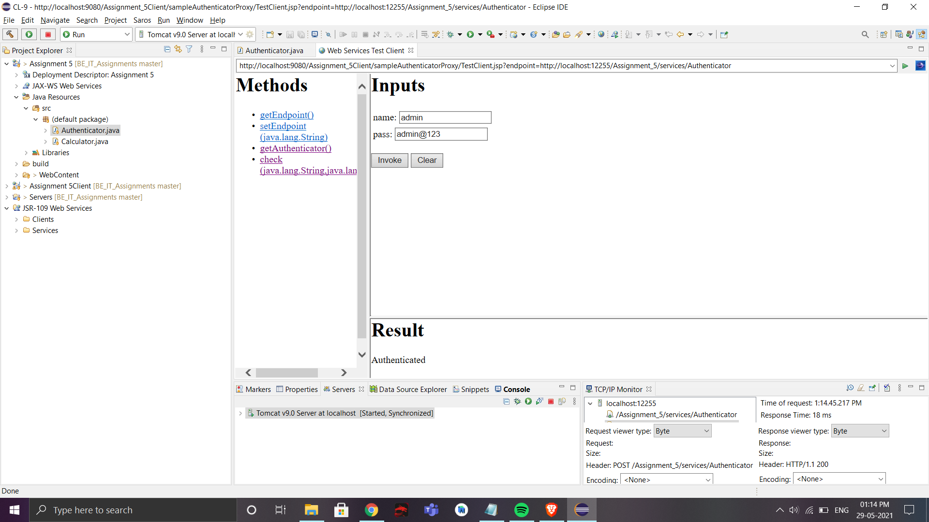

**Conclusion:**

Thus, in this assignment, I learned about web services and implemented the SOAP and REST web services in java.